**Create a Sponsored Post for Instagram**

**Introduction :**

In the dynamic and visually captivating world of social media, Instagram stands as a potent platform for both individuals and businesses alike. As Instagram's user base continues to grow, it has become an essential channel for brands to engage with their target audience and promote their products or services. One of the most effective ways to do this is through sponsored posts, where businesses partner with influential content creators to deliver their message to a wider and more receptive audience. In this project, we will explore the art and science of creating a sponsored post for Instagram, shedding light on the strategies, best practices, and creative elements that come together to craft a compelling and impactful Instagram promotion. Whether you are a marketing professional seeking to maximize the potential of sponsored content or an aspiring Instagram influencer looking to collaborate with brands, this guide will equip you with the knowledge and insights needed to succeed in the realm of sponsored Instagram posts.

**Brand Name & Category :**

Our brand name is “Teachza”. We are Introducing the brand for “Edutech Platform” category. we aim to create EduTech Platform that offers a personalized and adaptive learning environment that accommodates individual aspirations, schedules, and preferences. We believe that everyone should have the opportunity to unlock their full potential and achieve their educational goals, and our platform is dedicated to making this a reality.

**Target Audience:**

1. **Students:**
   * College or university students seeking effective knowledge.
   * They looking for a gateway to the job opportunity.

**Brand Email:**

Introducing our email ID: [teachzaedutecplatform@gmail.com](mailto:teachzaedutecplatform@gmail.com). College students can contact for all their educational technology needs, inquiries, or collaborations. We’re here to empower the future of education through this mailid

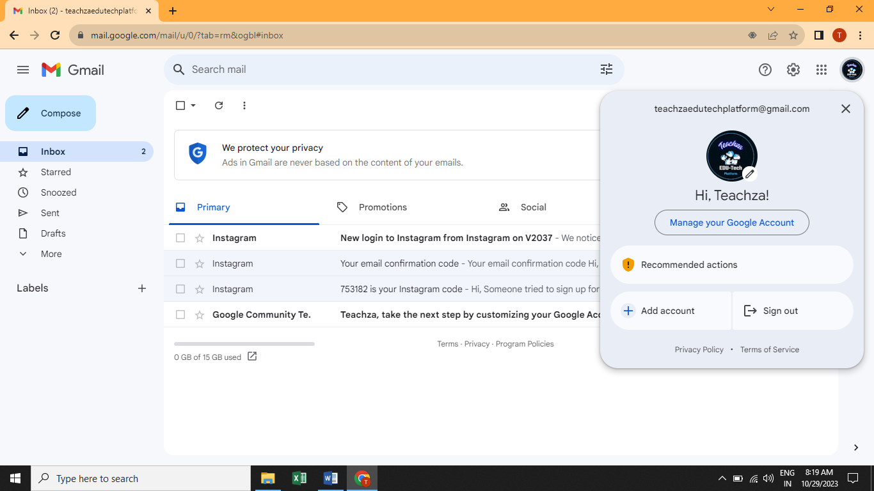

**Brand Instagram page :**

<https://instagram.com/teachzaedutech?igshid=YWYwM2I1ZDdmOQ>== this is our Instagram page id . students can contact for all their educational technology needs, inquiries, or collaborations. We’re here to empower the future of education through this Instagram page.

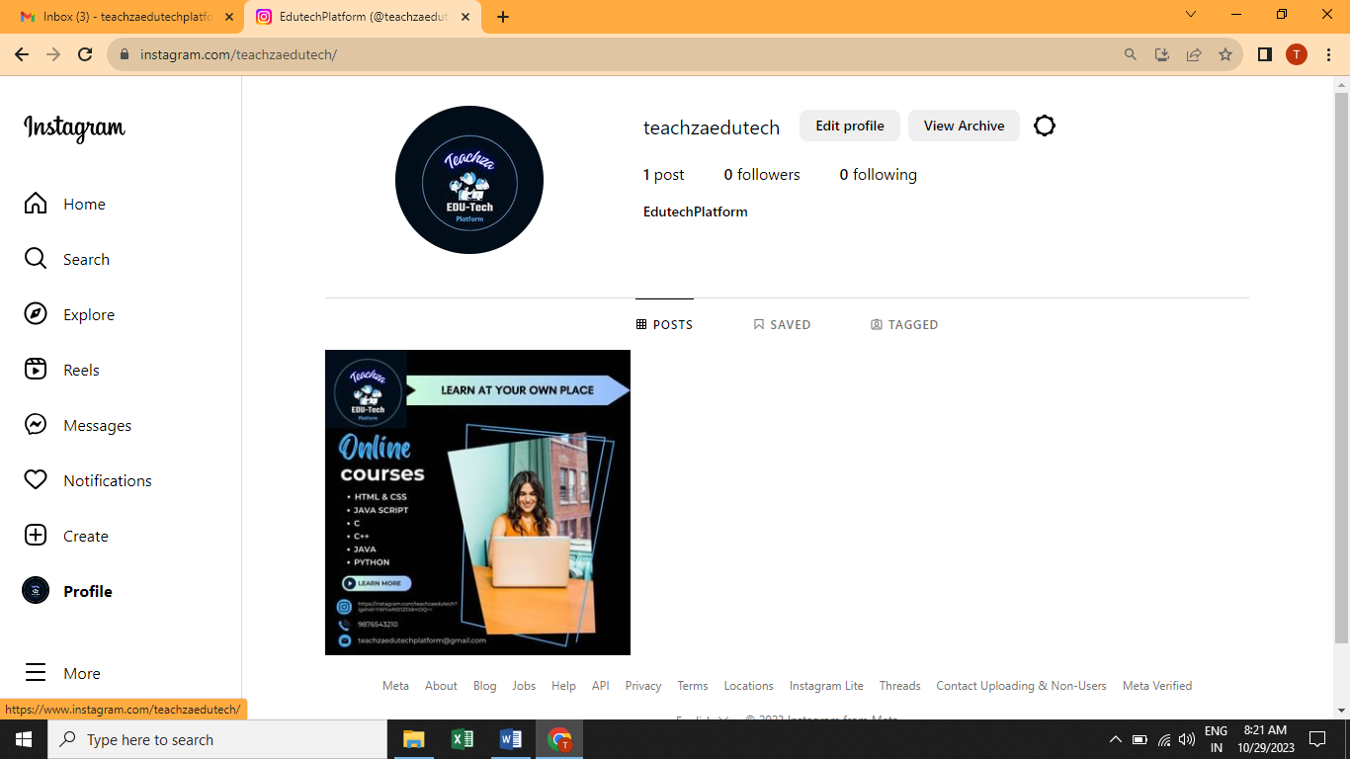

**Steps involved for Designing a sponsored instagram post using Canva:**

The following steps are involved to design sponsored post for an Instagram for promoting our brand name “Techza”.

# 1.Navigation

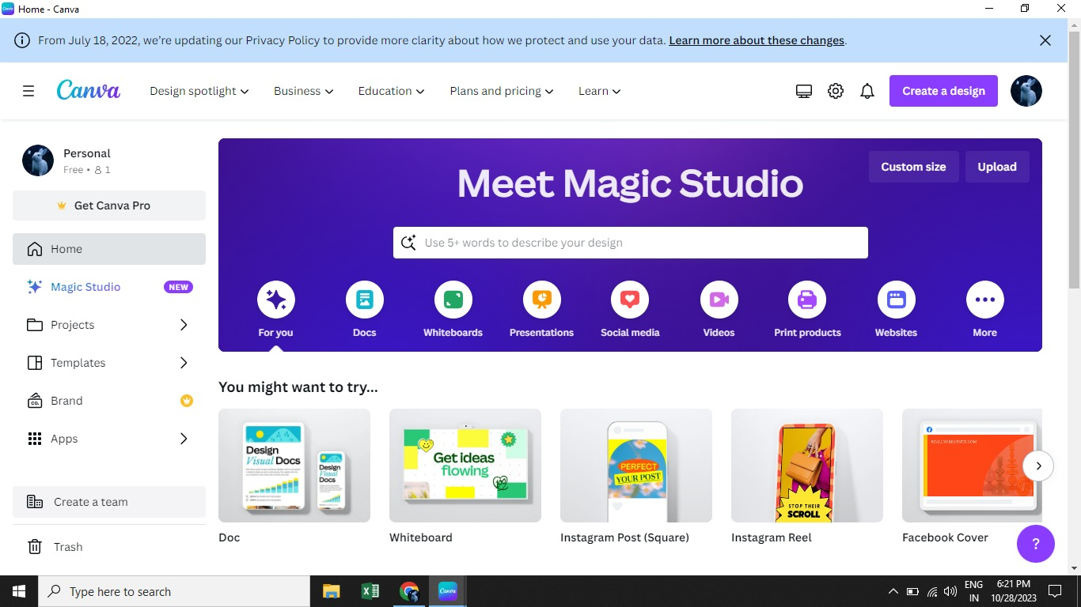

# 2.Choose any format

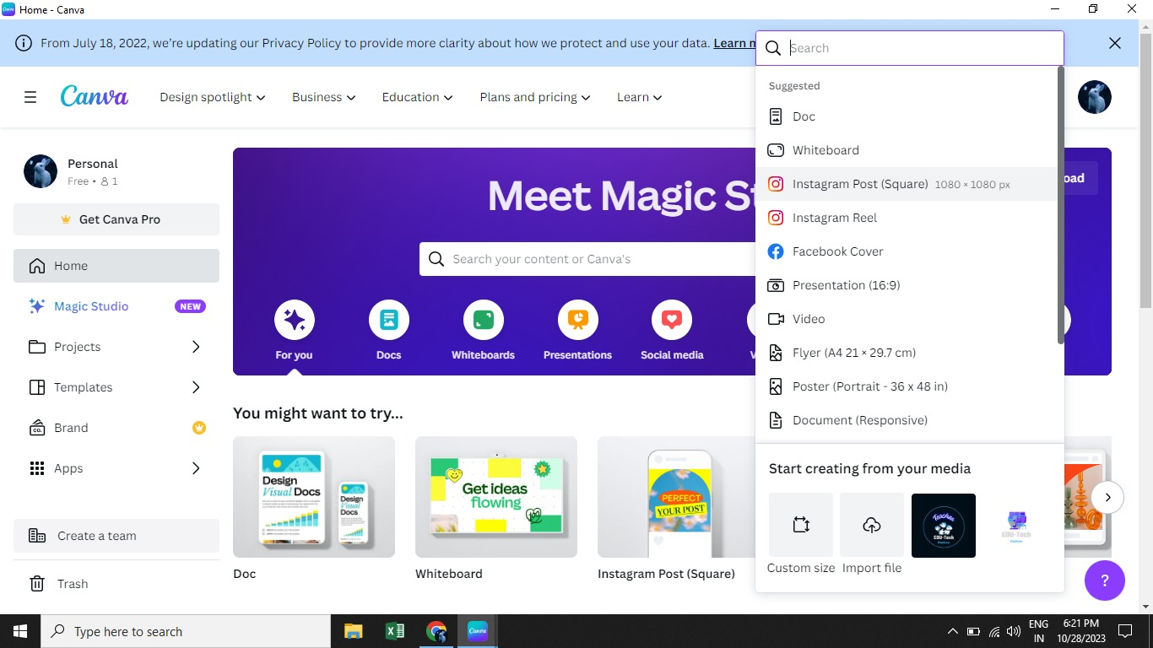

# 3.Create design

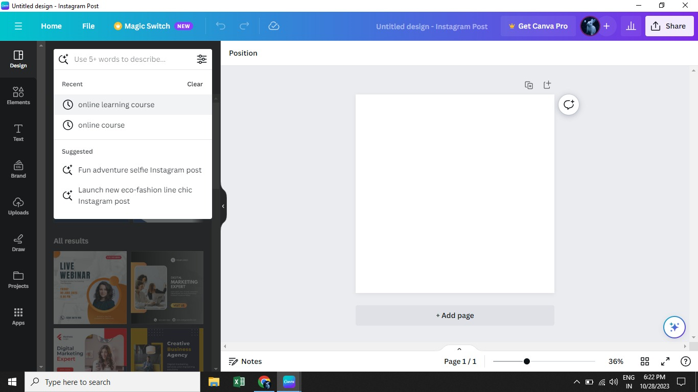

# 4.Choose Template

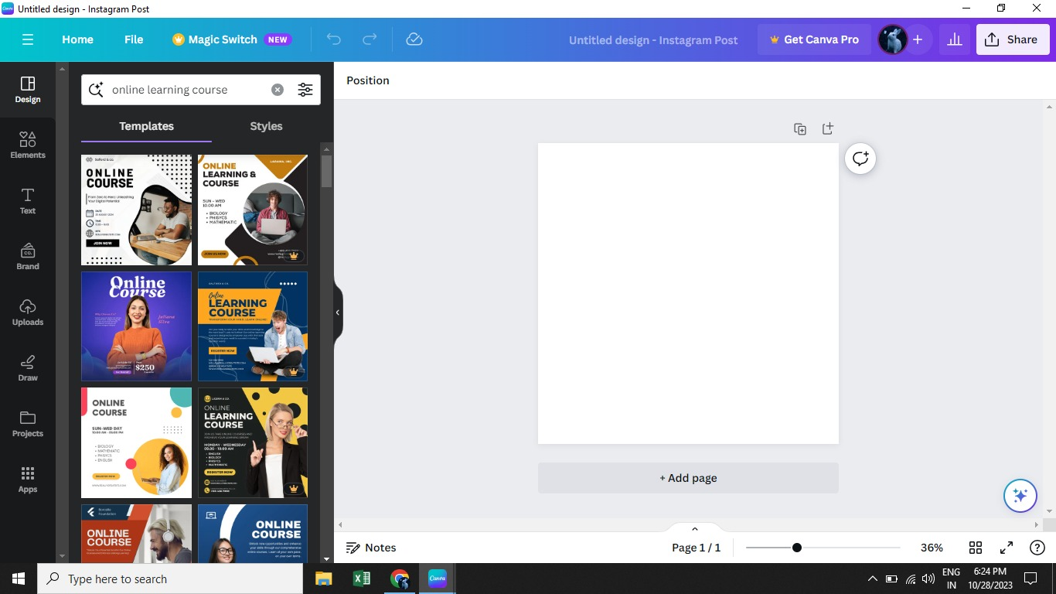

# 5.Click Upload

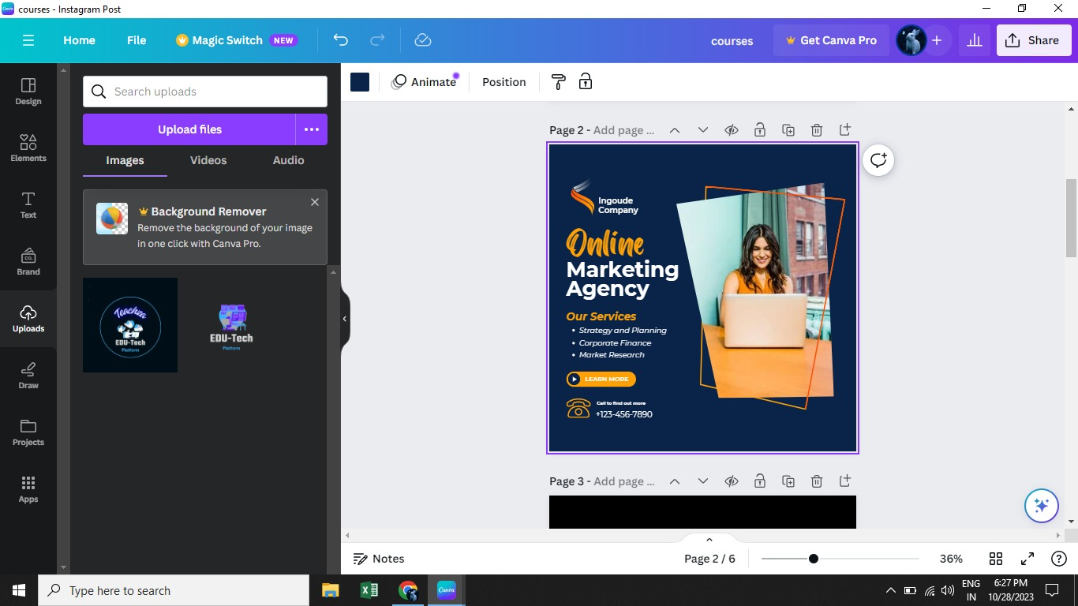

# 6.Upload Logo

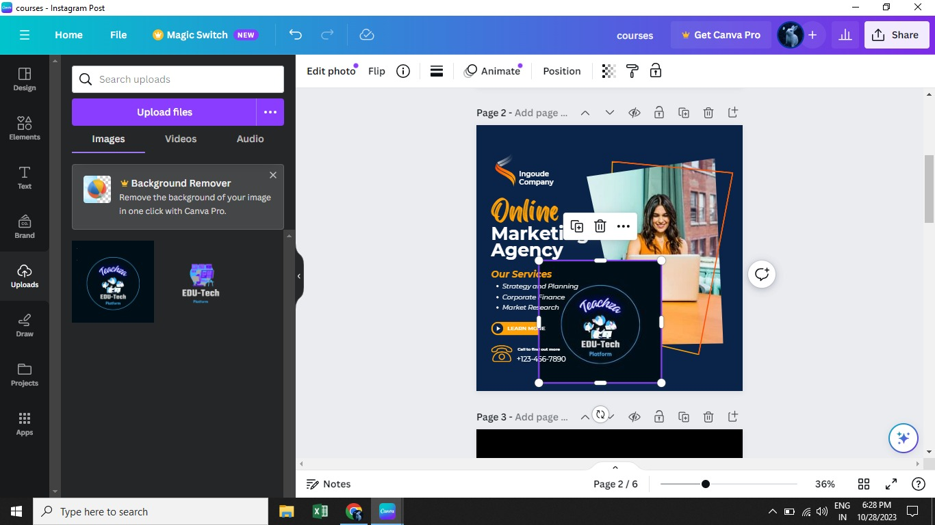

# 7.Change text Color

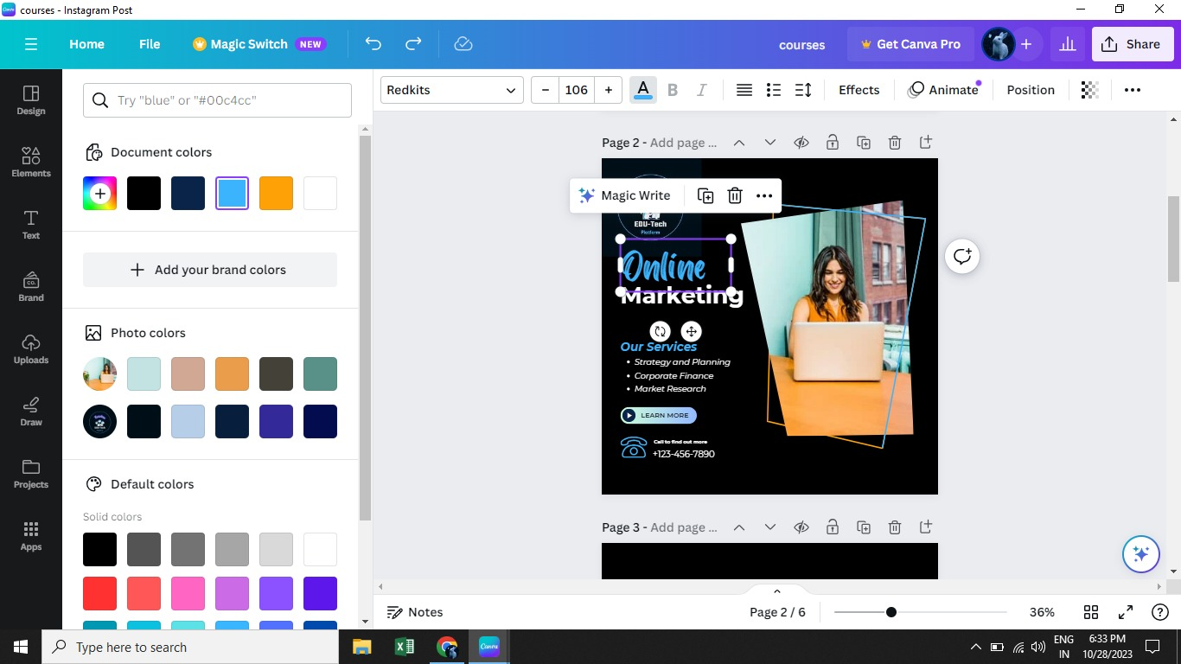

# 8.Edit text color

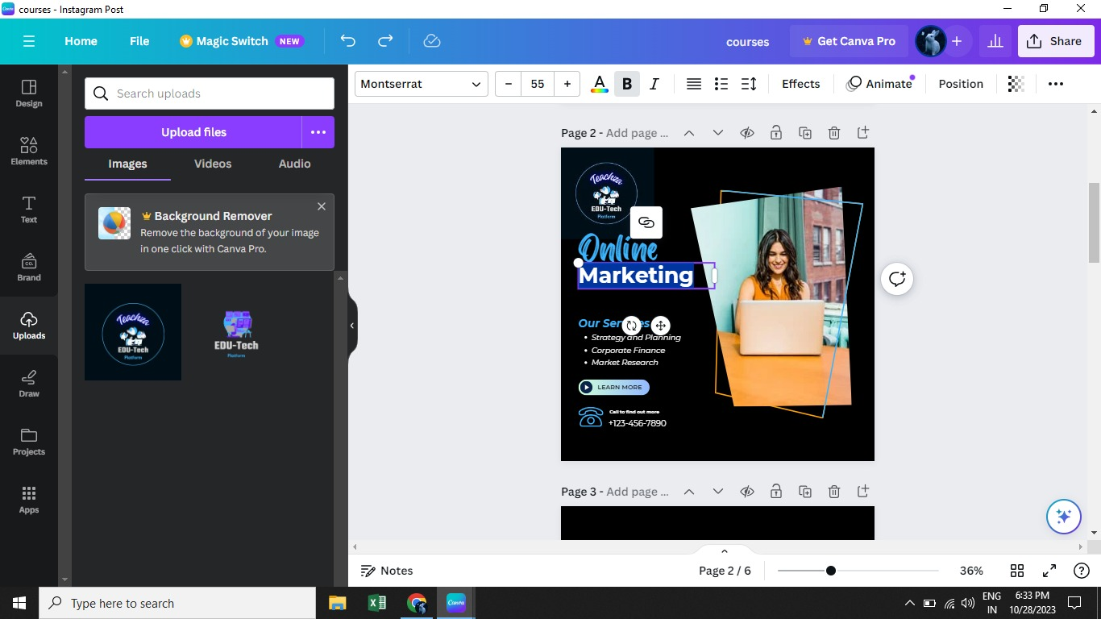

# 9.Add text box

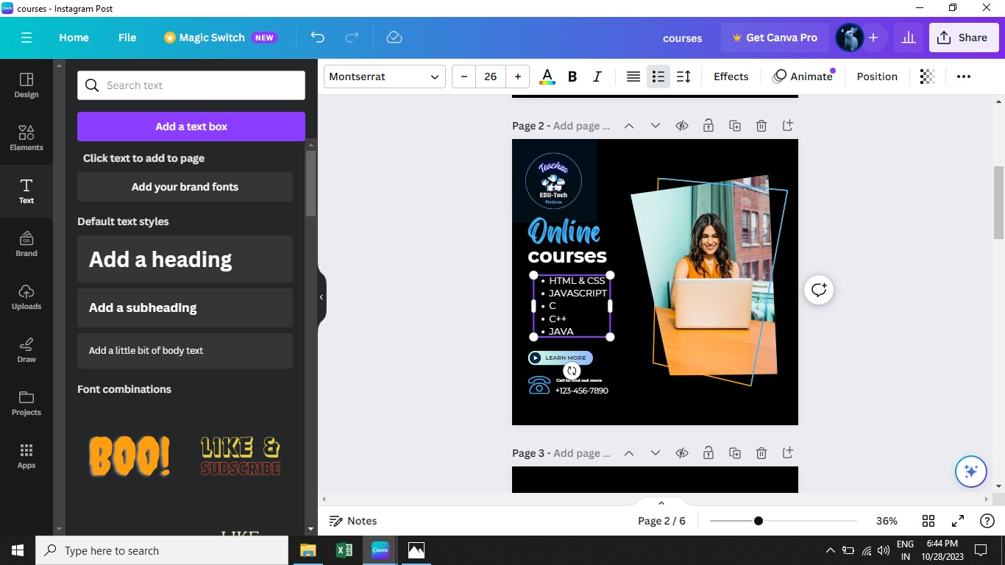

# 10.Line Spacing & Letter Spacing

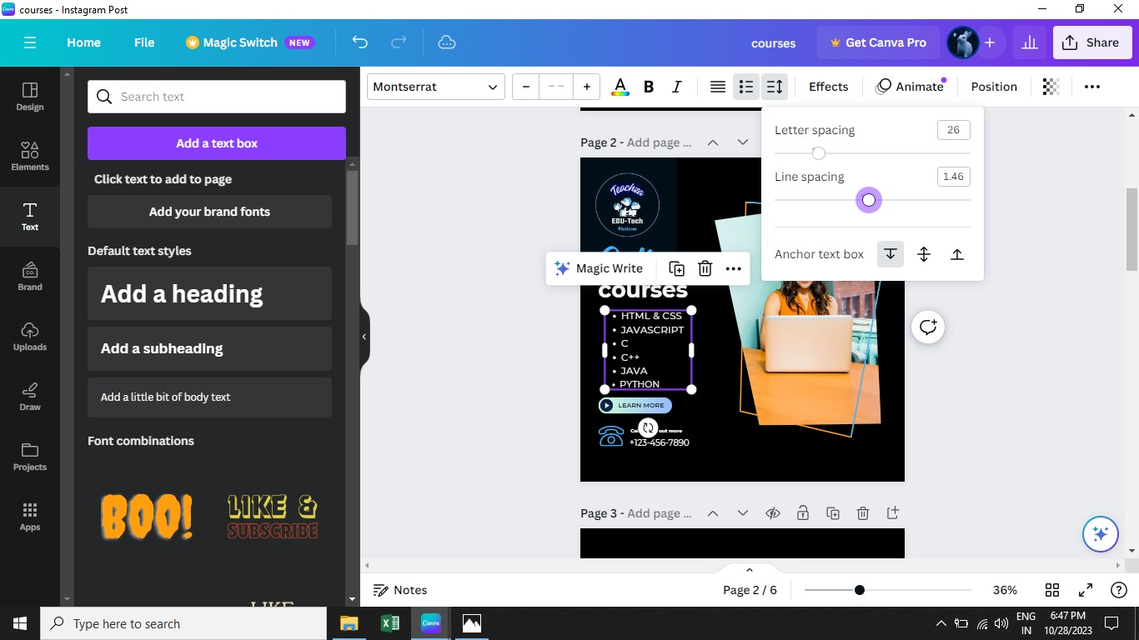

# 11.Font size

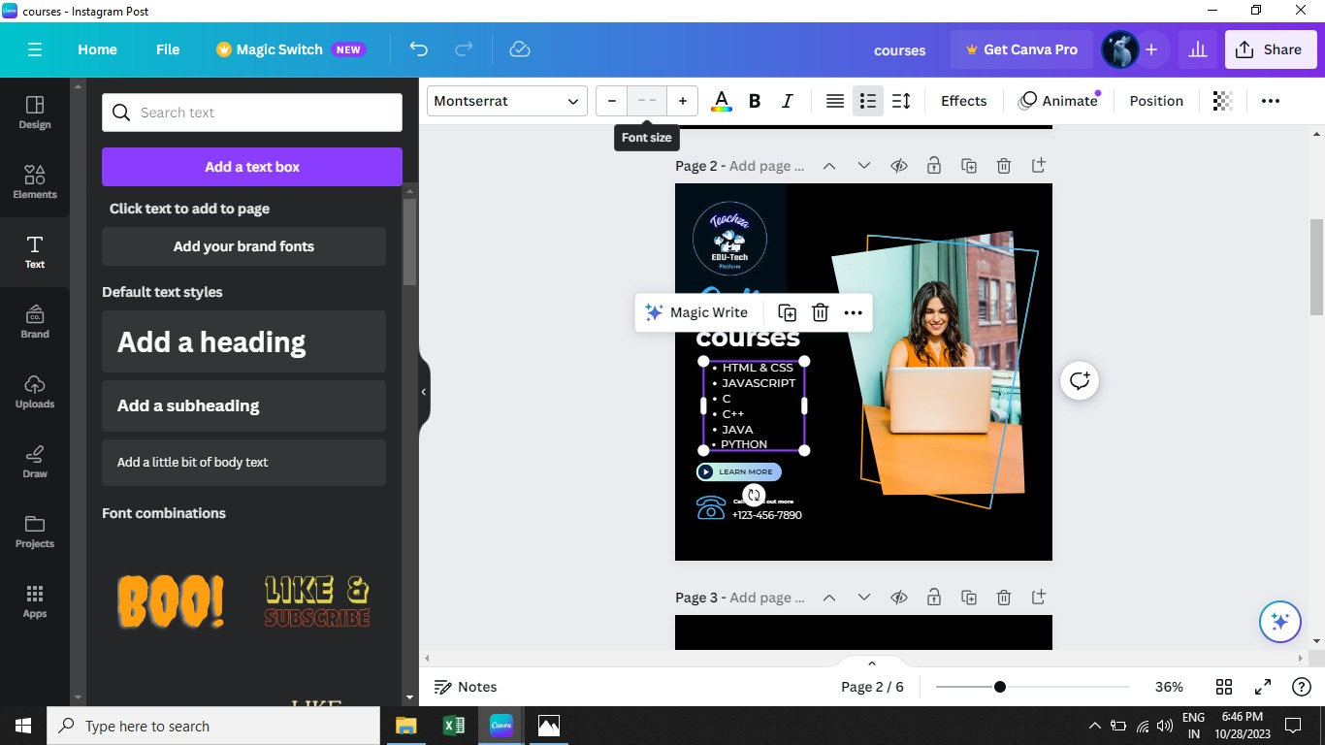

# 12.Upper Case & Lower Case

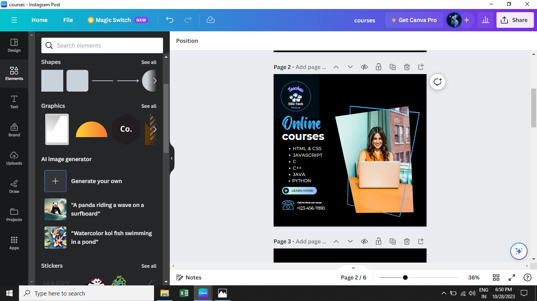

# 14.Search Element Click

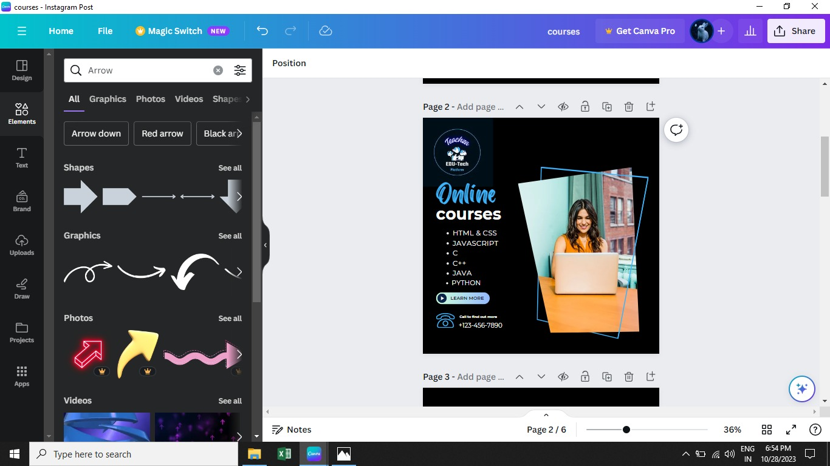

# 15.Click See all Element

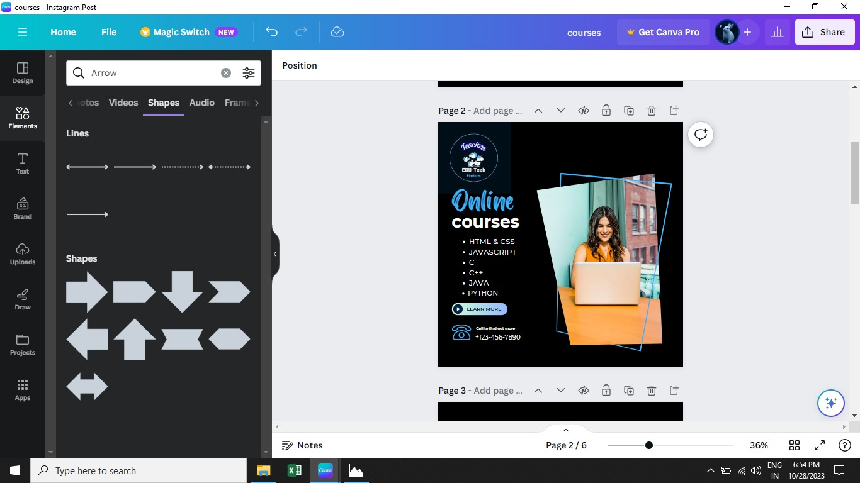

# 16.Add Own Content

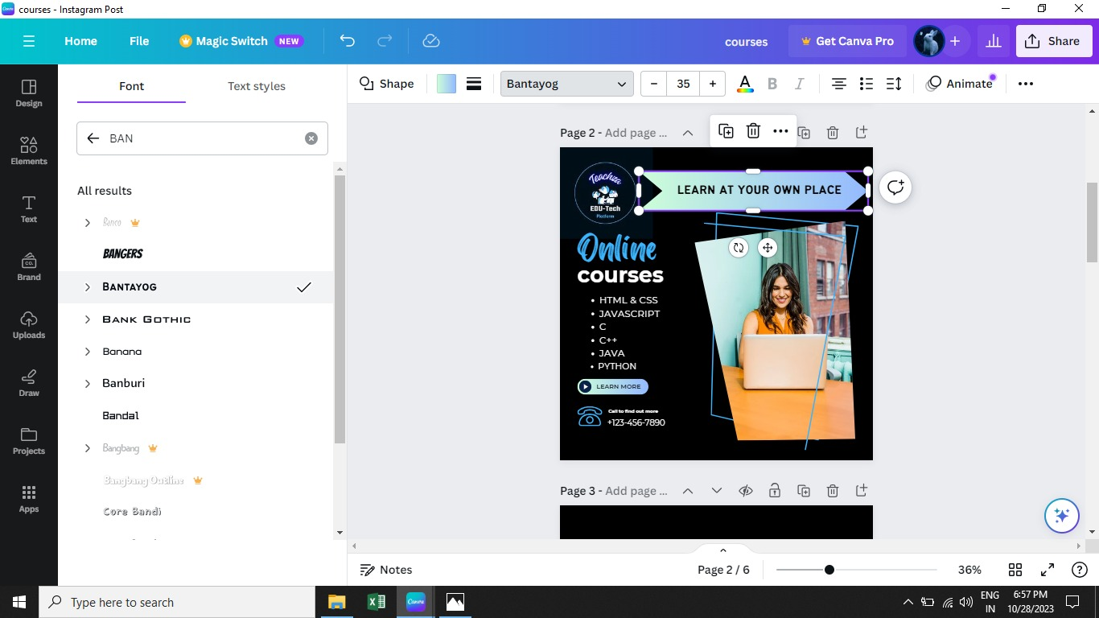

# 17.Add More Graphic Element

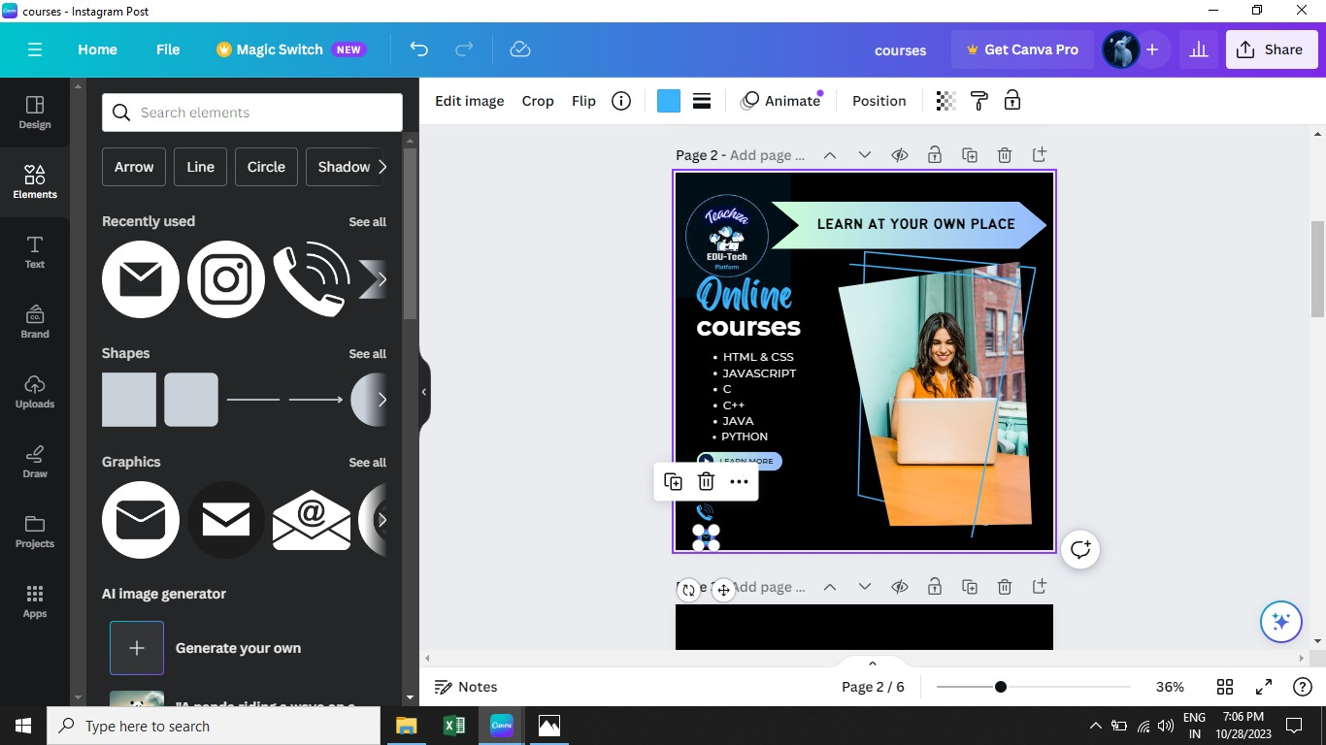

# 18.Click Duplicate Element

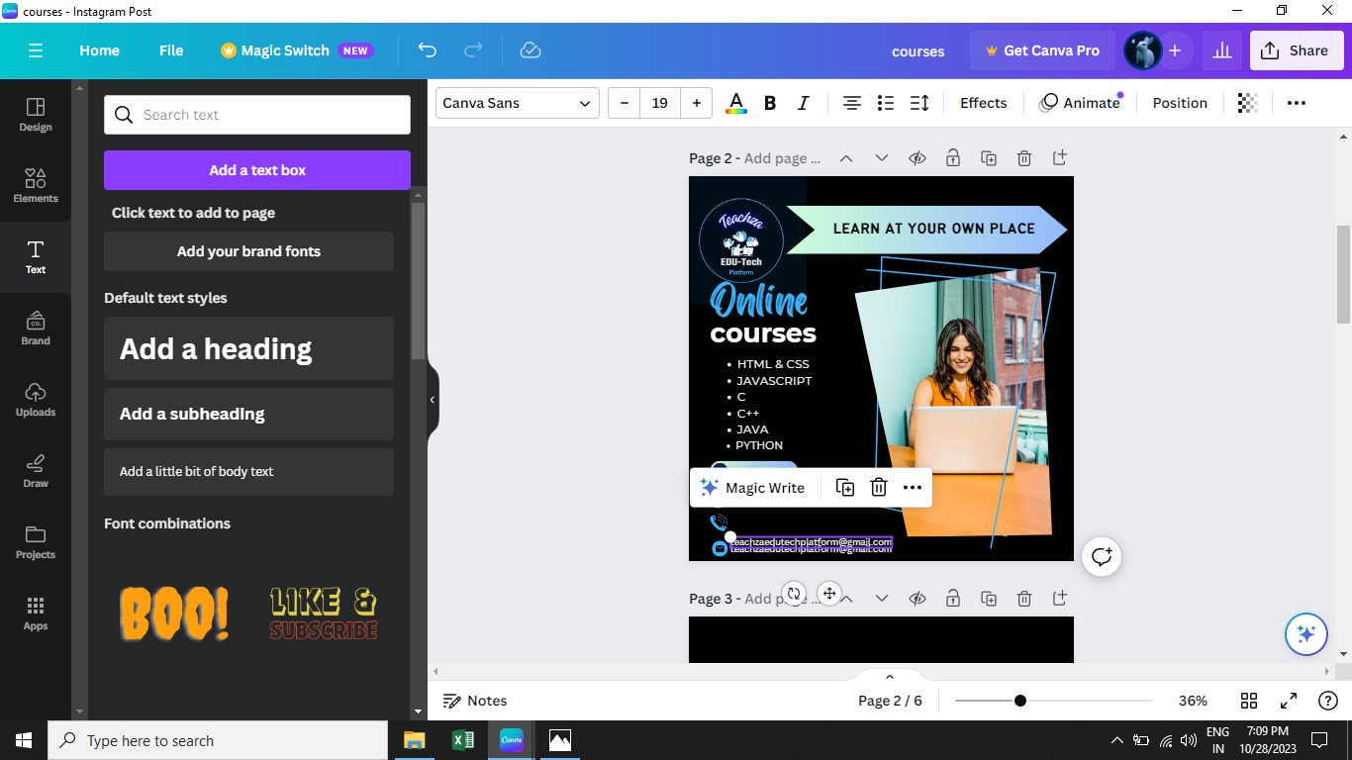

# 19.Text Effect

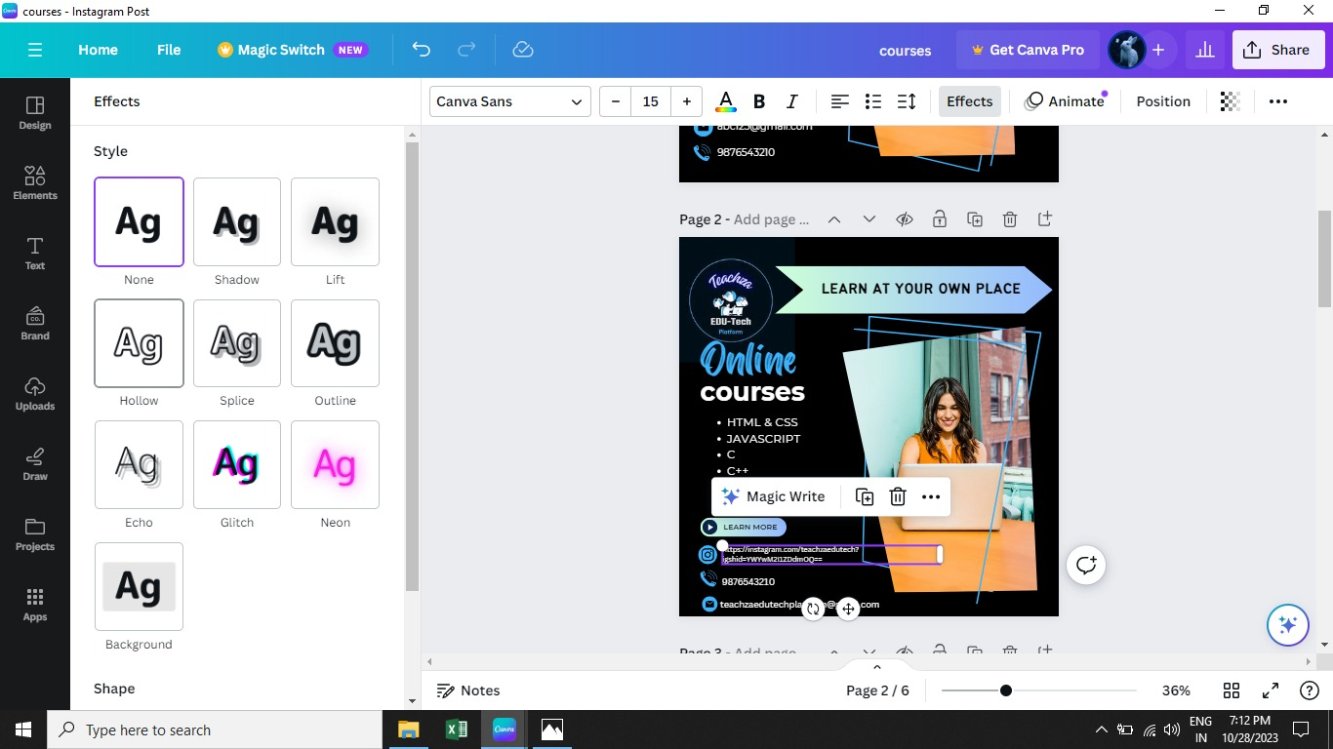

# 20.Layer

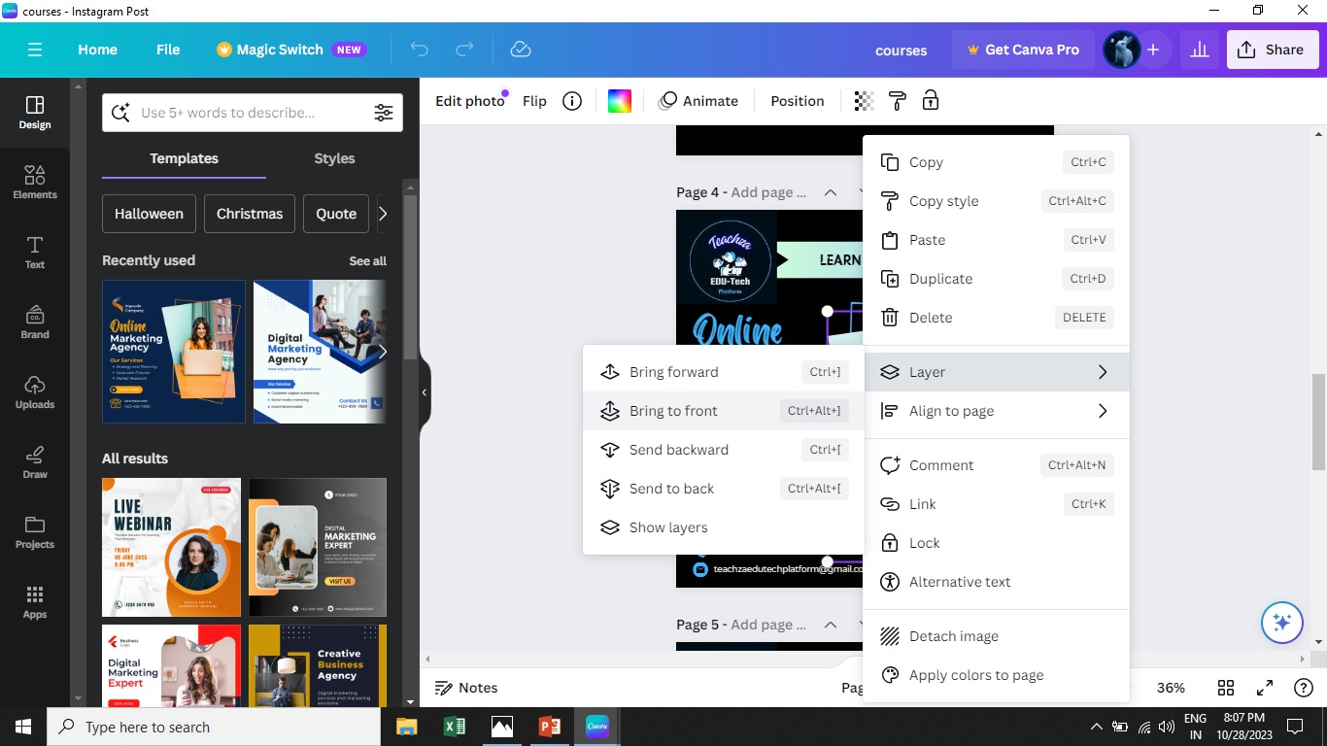

# 21.Adjust Length

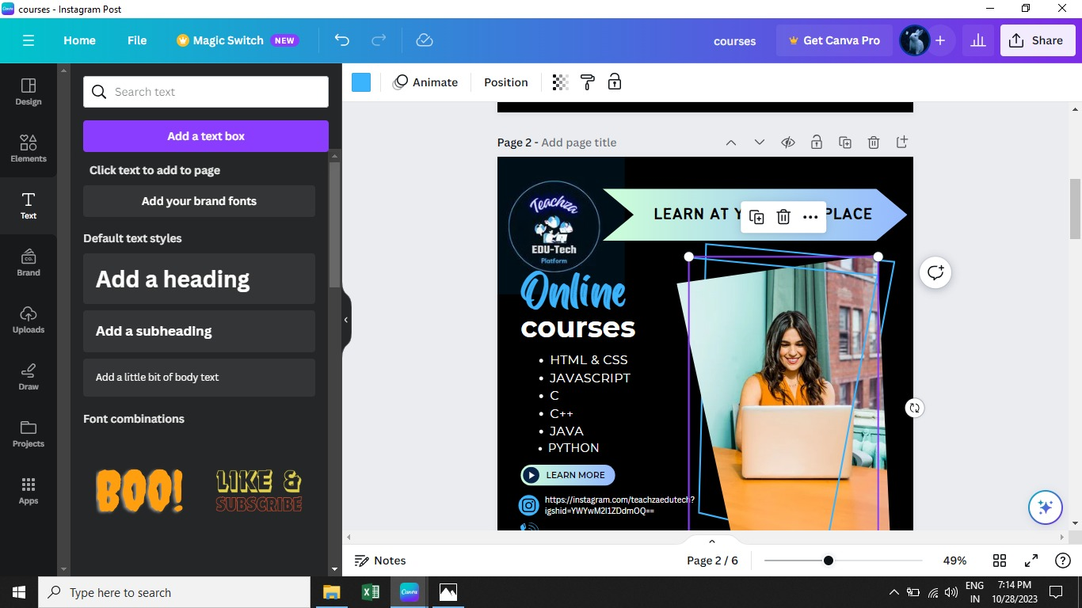

# 22.Click Share icon

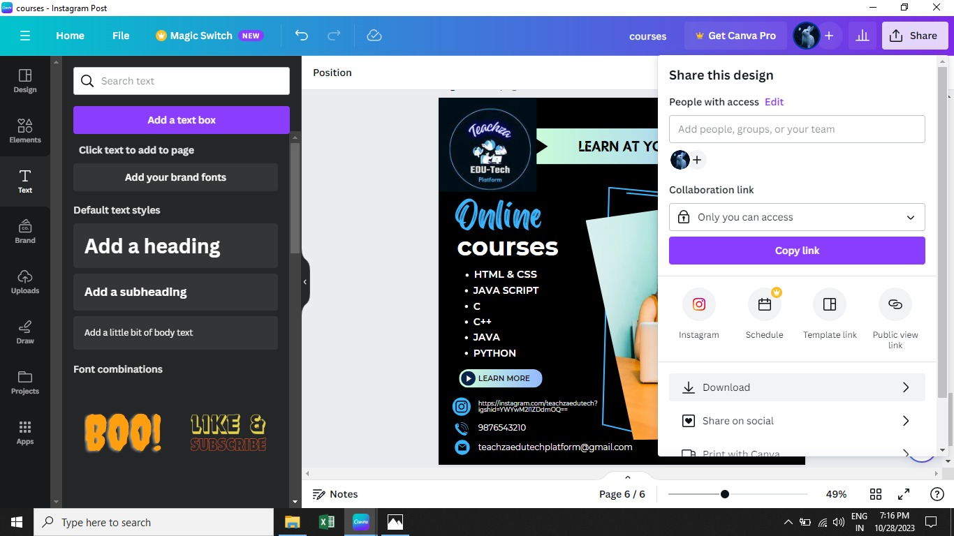

# 23.Click Download

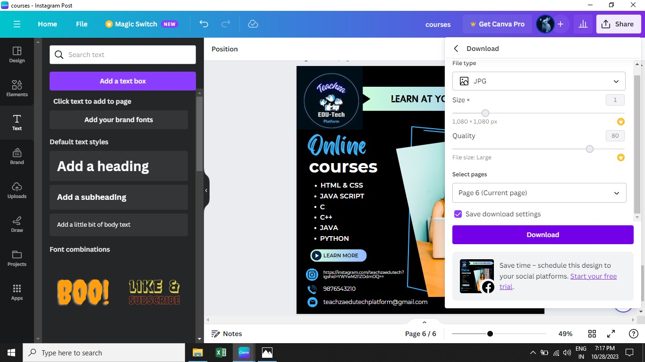

# 24.Final Designed Sponsored Post for Instagram to promote Teachza Brand:



**Conclusion:**

In conclusion, the completion of this project marks a significant milestone in our digital marketing efforts. Creating a sponsored post for Instagram and documenting the step-by-step process with screenshots has allowed us to harness the power of one of the most influential social media platforms. By following the clear and concise instructions provided in this project, we have not only expanded our reach and engaged with our target audience but have also strengthened our brand's online presence. The carefully curated screenshots provide a valuable resource for both our team and future collaborators, ensuring that the process remains accessible and replicable. This project exemplifies the seamless fusion of creativity, technology, and strategy, highlighting the ever-evolving landscape of digital marketing. As we move forward, we should not only celebrate our success but also use this project as a stepping stone for further innovation and exploration in the digital realm. We must continuously adapt to the dynamic nature of social media marketing, staying at the forefront of trends and technologies. With dedication and adaptability, we can continue to create impactful sponsored posts on Instagram and build a stronger, more engaging online presence for our brand.

## 